



**Applied Physics for Scientists and Engineers**

**Lab Report: Determining AC frequency by Sanometer**

|  |  |  |
| --- | --- | --- |
| **Submitted to**  Sir. Haseen Ullah Jan |  | |
| **Submitted by**  Muhammad Sadeeq | Computer system Engineering |  |
| Section C | Roll No. 75025 |  |



# **Apparatus:**

Following apparatus is used for this experiment:

1. Sanometer
2. Weights
3. Step Down Transformer
4. AC main Supply
5. AC Ammeter
6. Rheostat
7. Wedge



# **Procedure:**

Procedure is as following:

1. Arrange the apparatus as shown in the ﬁgure below.
2. Switch the power supply on.
3. Start increasing the distance between the two wedges.
4. Place the magnet in between the wire.
5. Set the distance to obtain maximum vibration in the wire.
6. Repeat this process by placing more weight in the pan.
7. Note the reading as the procedure follows



# **Figure:**

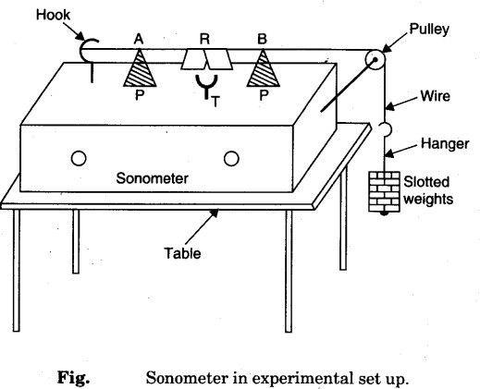

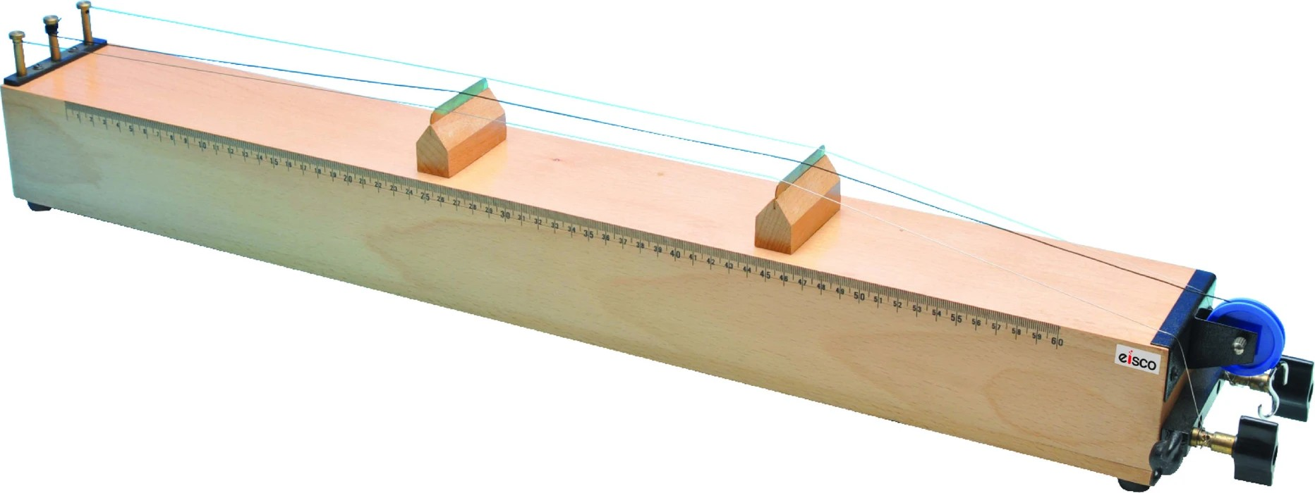



**Readings:**

**Acceptance of the work is contingent on the following acceptance criteria:**

|  |  |  |  |  |  |  |
| --- | --- | --- | --- | --- | --- | --- |
| S.  No. | Load in grams | Position of Wedge L1 | Position of Wedge L2 | Tension T=mg | L2-L1 | F= 1 √*T*  2*L* μ |
| 1. | 1000g | 4cm | 49cm | 980000 dyne | 45 cm | 48.24 Hz |
| 2. | 2000g | 4cm | 64cm | 1960000 dyne | 60 cm | 51.16 Hz |
| 3. | 3000g | 4cm | 77cm | 2940000 dyne | 73 cm | 51.50 Hz |

Mean Value=

48.24+51.16+51.50

3

Mean Value= 50.3 Hz ≈ 50 Hz



# **Precautions:**

* 1. Do snug connections.
  2. Mark the readings where vibration of the sonometer wire is maximum.
  3. Protect yourself from Live AC wires.
  4. DO NOT DO THIS EXPERIMENT WITH 220 VOLTS directly.